# System and Software Engineering

# **Project Name: Sequence Analysis Tools**

Client: I need a proper sequence analysis tools. Can you make it ? I’m now telling you the requirements to do for this software.

**Requirements:**

The Project requirement gathering / collection :

Functional requirements:

* Calculate the GC count
* Find the reverse complement
* Find codon usage count and show it
* Sequence alignment for counting gaps, similarity, dissimilarity and score count
* DNA translation
* Convert DNA to mRNA

Non-Functional requirements:

* User friendly GUI
* Performance : quick result for DNA sequences
* Reliability: error handle inputs and provide meaningful error message
* The system must run on multiple operating system.

**Requirement analysis:**

Users:

* Biologists
* Researchers
* Students

Data input give manually sequences or fasta format file

Processes:

Reading input from the user and performing the require computation and displaying a GUI.

**Requirement Validation:**  
 for Requirements, created a prototype and feedback from users and perform unit testing, integration testing and user acceptance testing to ensure the requirements and conduct a review with stakeholder to validate.

Module identify:

* User interface module : using GUI(tkinter) and handle user input and display the result
* Sequences analysis modules : performs DNA sequences and calculation the requirement elicitation
* Allignment module : perform two DNA sequences and display the result

Use case Diagram:

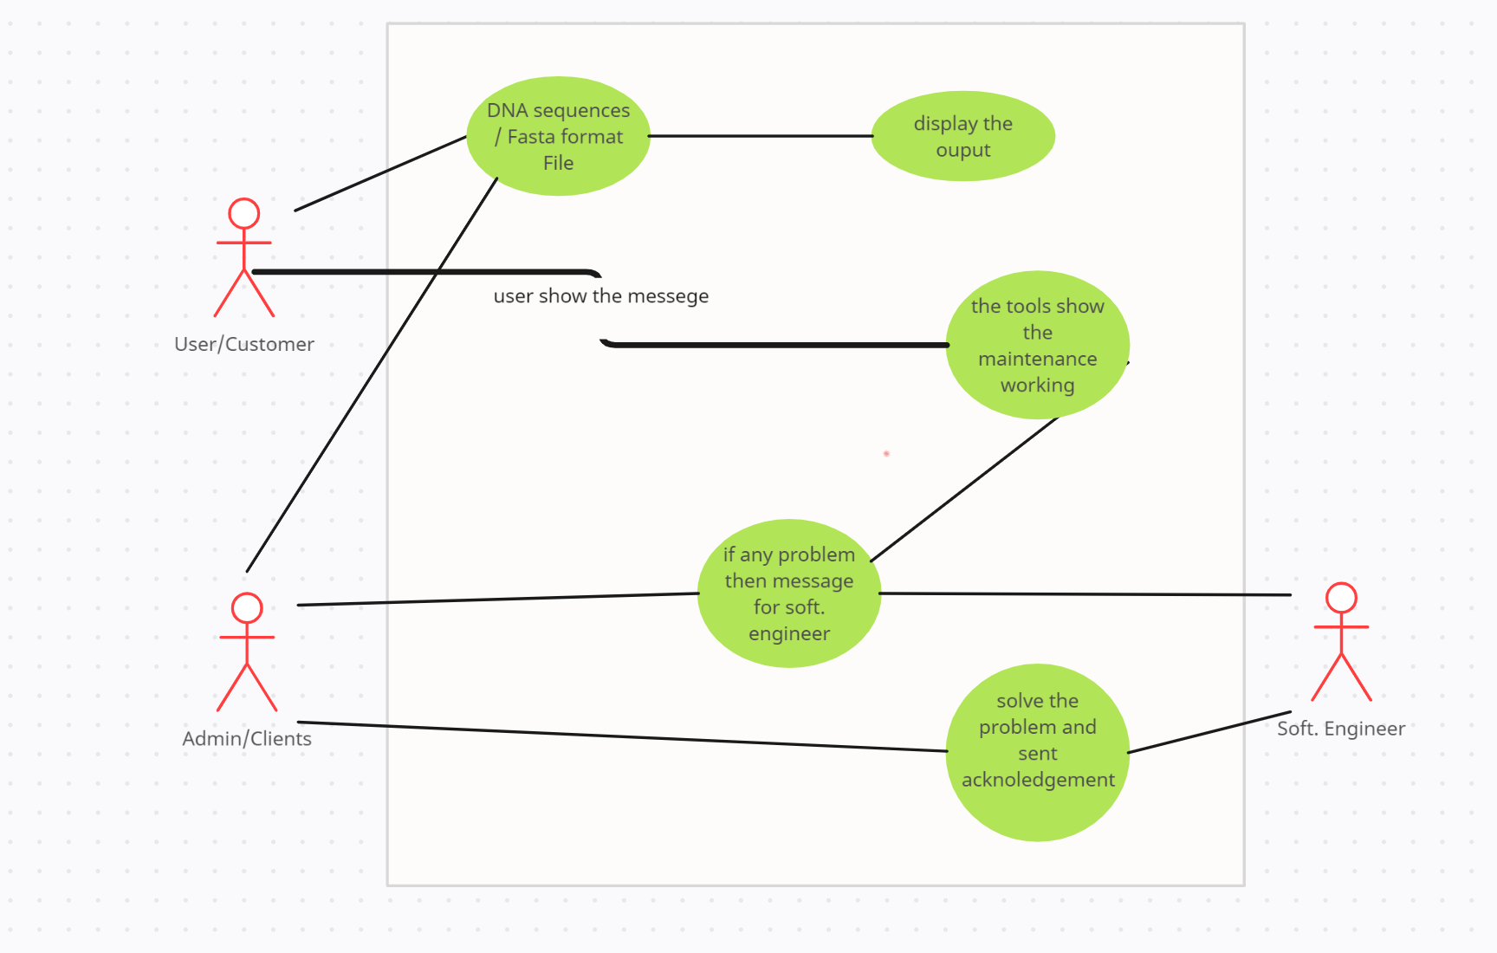

UI:

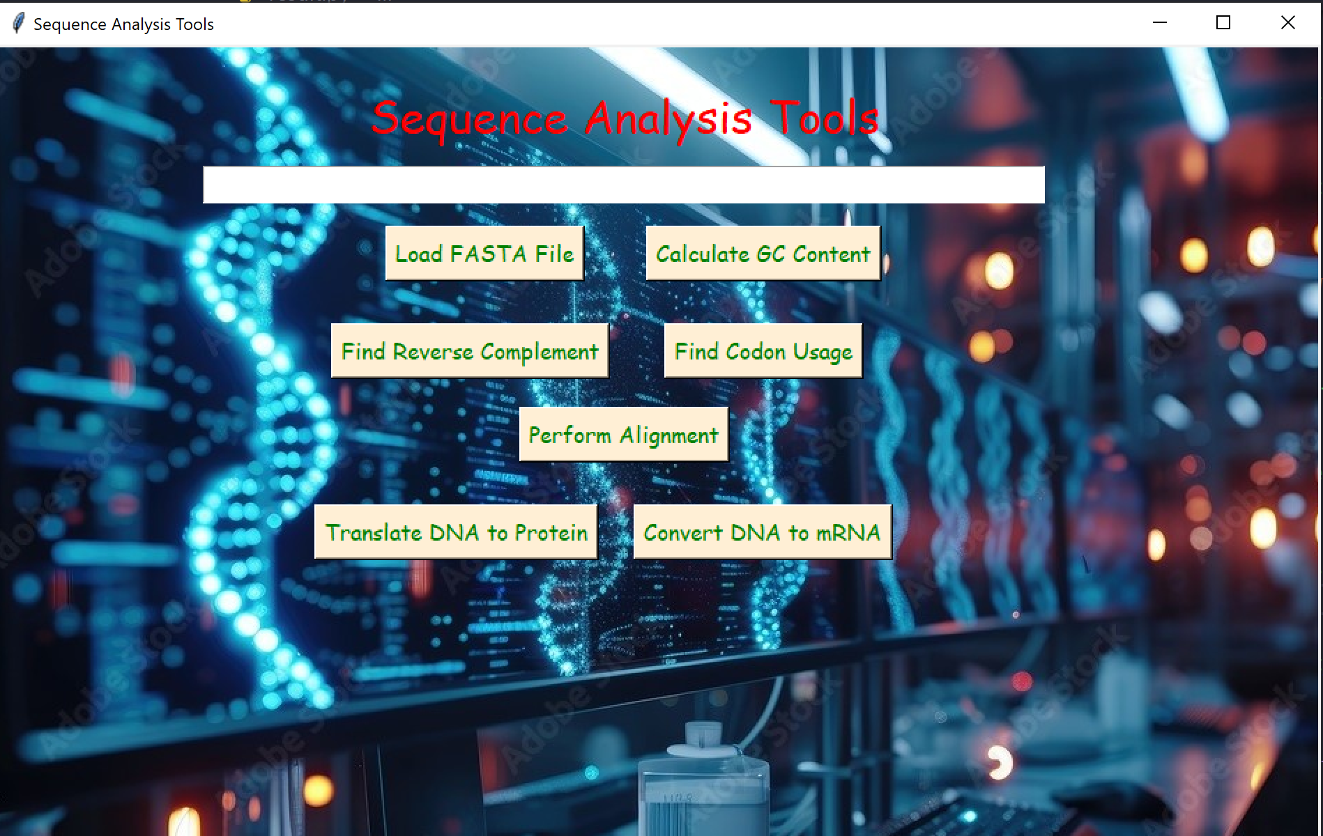

Object oriented / class diagram:

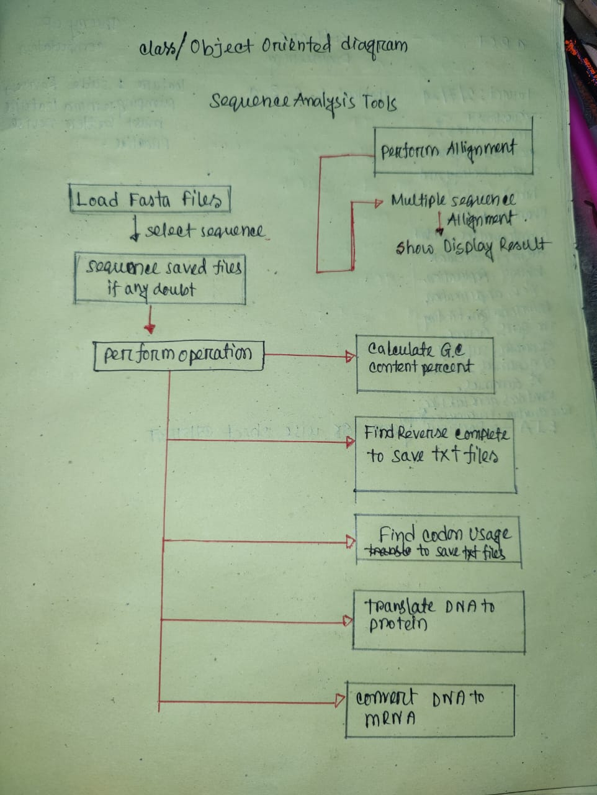

UML diagram:

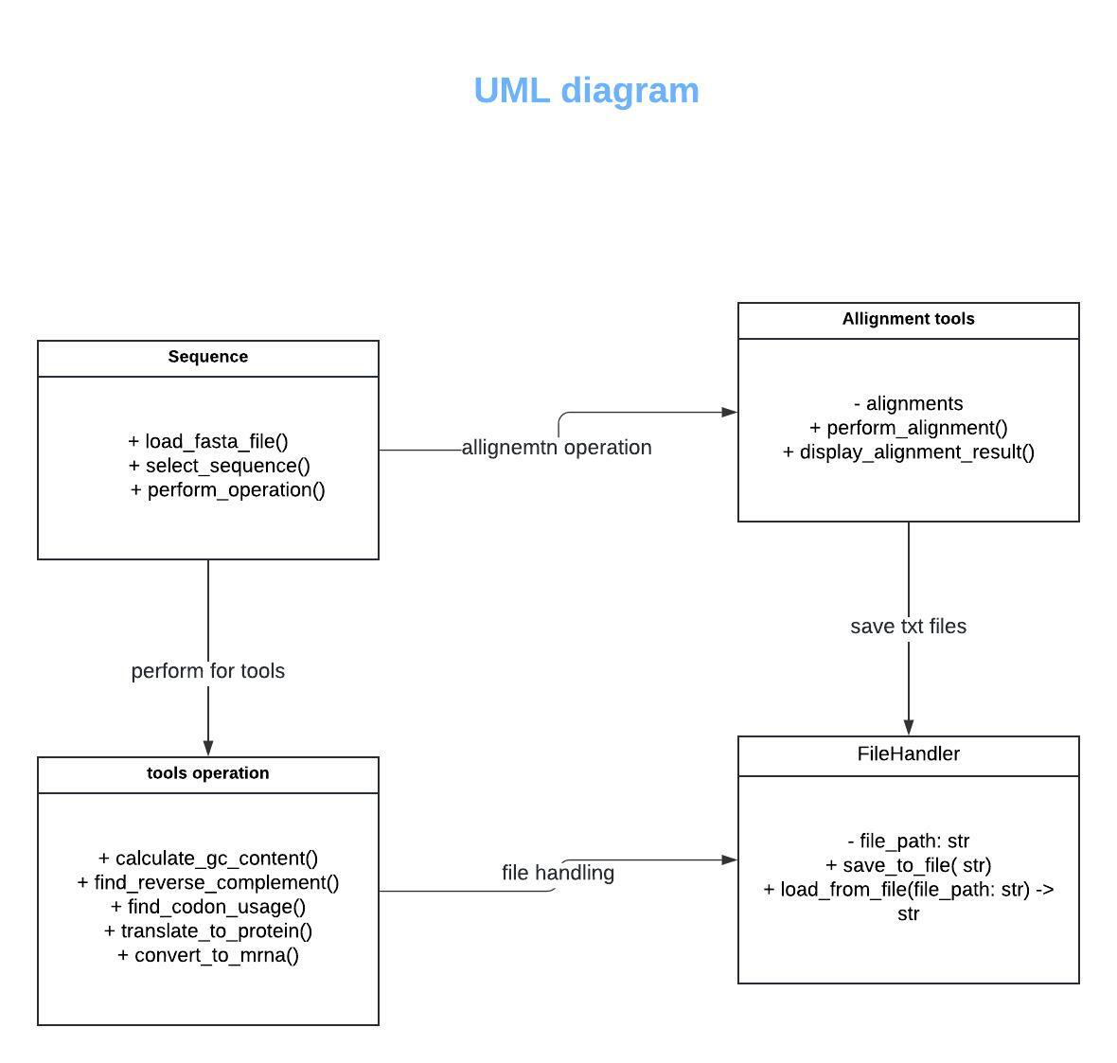

**Software testing**

* Software testing for this project using fasta files –

Fasta files to load for this project and check show result for all perform activity.

Multiple sequence Allignment and pairwise sequence allignement show display using fasta files.

**Estimation for Project:**

* I use the bottom up approach for this project work accurately and clear scenario for understanding how much I effort this project.